Faculty of Computing



Name: Maryam Mehreen(35889)

[Computer Communications & Network]

Lab Manual

**LAB - 1**

|  |  |
| --- | --- |
| **Course** | **Computer Communications and Network Lab** |
| **Course Instructor** | **Ms. Hafsah Mahmood** |
| **Credit Hour** | **1** |
| **Lab No.** | **1** |
| **Lab Subject** | **Computer Network Configuration Commands** |
| **Lab Objective** | 1. Introduction to IP addressing 2. Identify tools used for discovering a computer’s network configuration with various operating systems. 3. Gather information, including the connection, host name, MAC (Layer 2) Address, and TCP/IP Network (layer 3) 4. Compare the network information to that of other PCs on the network. 5. Learn to use the TCP/IP packet Internet groper (ping) command from a workstation. 6. Learn to use the trace route (tracert) command from a workstation. 7. Observe name-resolution occurrences using WINS and DNS servers. |
| **Tools** | PC/Laptop, Lab Manual |

**Background**

This lab assumes that you are using Windows NT/2000/XP or Windows 10. This is nondestructive lab that you can perform on any host without changing the system’s configuration.

Ideally, you perform this lab in a LAN environment that connects to the Internet. You can use a single remote connection via a dialup modem or DSL. You will need the IP address information which the instructor should provide.

**IP Addressing**

IP address stands for “Internet Protocol address.” The Internet Protocol is a set of rules for communication over the internet, such as sending mail, streaming video, or connecting to a website.  An IP address, or Internet Protocol address, is a series of numbers that identifies any device on a network. Computers use IP addresses to communicate with each other both over the internet as well as on other networks.

IP addresses are the identifier that allows information to be sent between devices on a network: they contain location information and make devices accessible for communication. The internet needs a way to differentiate between different computers, routers, and websites. IP addresses provide a way of doing so and form an essential part of how the internet works.

An IP address is a string of numbers separated by periods. IP addresses are expressed as a set of four numbers — an example address might be 192.158.1.38. Each number in the set can range from 0 to 255. So, the full IP addressing range goes from 0.0.0.0 to 255.255.255.255.

The internet protocols manage the process of assigning each unique device its own IP address. (Internet protocols do other things as well, such as routing internet traffic.) This way, it’s easy to see which devices on the internet are sending, requesting, and receiving what information.

IP addresses are like telephone numbers, and they serve the same purpose. When you contact someone, your phone number identifies who you are, and it assures the person who answers the phone that you are who you say you are. IP addresses do the exact same thing when you’re online — that’s why **every single device that is connected to the internet has an IP address**.

There are two types of IP addresses: [IPv4 and IPv6](https://avast.com/c-ipv4-vs-ipv6-addresses). It’s easy to recognize the difference if you count the numbers. IPv4 addresses contain a series of four numbers, ranging from 0 (except the first one) to 255, each separated from the next by a period — such as 5.62.42.77.

IPv6 addresses are represented as eight groups of four hexadecimal digits, with the groups separated by colons. A typical IPv6 address might look like this: 2620:0aba2:0d01:2042:0100:8c4d:d370:72b4.

**Network Configuration**

**Part A Using ipconfig command**

**Step 1: Connect to the Internet**

Establish and verify connectivity to the Internet. This step ensures the computer has an IP address.

**Step 2: Gather TCP/IP configuration information**

1. Windows NT/2000/XP: Use the start menu to open the command prompt (Start/Programs/Accessories/Command Prompt or Start/Programs/Command Prompt)

Windows 10: Press Window+R to open Run box. Then click ok to run a regular command prompt.

1. Type ipconfig and press Enter key.

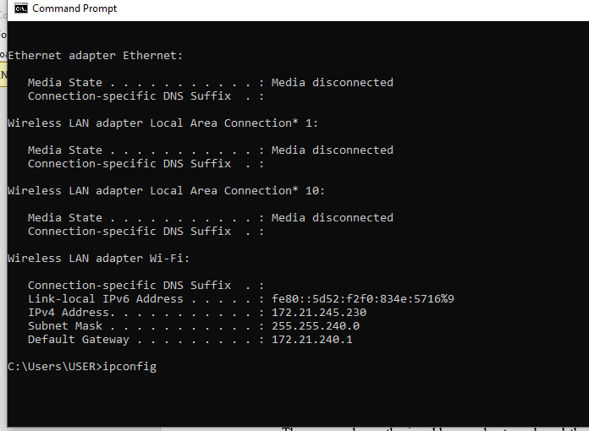

1. The screen shows the ip address, subnet mask and the default gateway. The ip address and the default gateway should be in the same network or subnet. Otherwise the host wouldn’t be able to communicate outside the network.

**Step 3: Record the following TCP/IP information for this computer**

1. IP address: 172.21.245.230
2. Subnet mask:255.255.240.0
3. Default Gateway: 172.21.240.
4. 1**Step 4: Compare this computer’s TCP/IP configuration to that of others on the LAN**

If this computer is on LAN, compare the information of several machines (Hosts).

1. Are there any similarities? Yes
2. What is similar about the IP address? Devices on the same LAN will have IP address that fall within the same subnet range.
3. What is similar about the default gateway? The entire default gateway is exactly the same as those for other devices on the LAN.
4. Is there anything similar in subnet mask? The entire subnet mask is same as those for other devices on the LAN
5. Record a couple of the IP addresses (of your nearby hosts)
6. 172.21.20.30
7. 172.21.245.230
8. 172.21.247.24
9. **Step 5: Check Additional TCP/IP configuration information**
10. To see more information, type ipconfig/all and press Enter key. The next figure shows the detailed IP configuration of this computer on the screen.

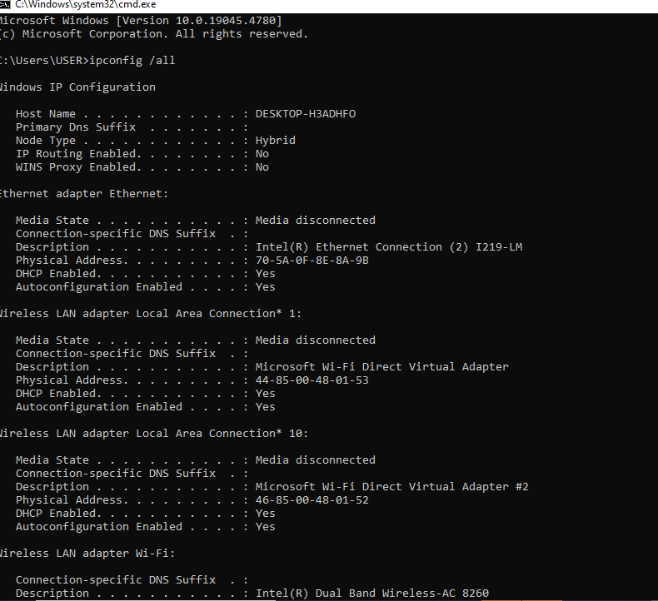

1. You should see the following information:
   1. The host name
   2. The physical address of this machine
   3. IP address
   4. Subnet mask
   5. Default gateway
   6. DNS servers
2. In the LAN, compare your results with a few nearby computers. What similarities do you see in the physical (MAC) address?

No similarities

Write down the computer’s host name: DESKTOP-H3ADHFO

1. Write down the host name of couple of other computers.
   1. DESKTOP-A21B23D
   2. DESKTOP-E2G1ARM
   3. DESKTOP-M5BA6FL
   4. DESKTOP-CIKRIAB

**Step 6: Close the screen when finished.**

**Part B Using PING TRACERT from a workstation**

**Establish and verify connectivity to the internet. This step ensures that the computer has an IP address.**

**Step 1:**

1. Open the command prompt.
2. Type ping, give space and type the IP address of a computer recorded in the previous lab.

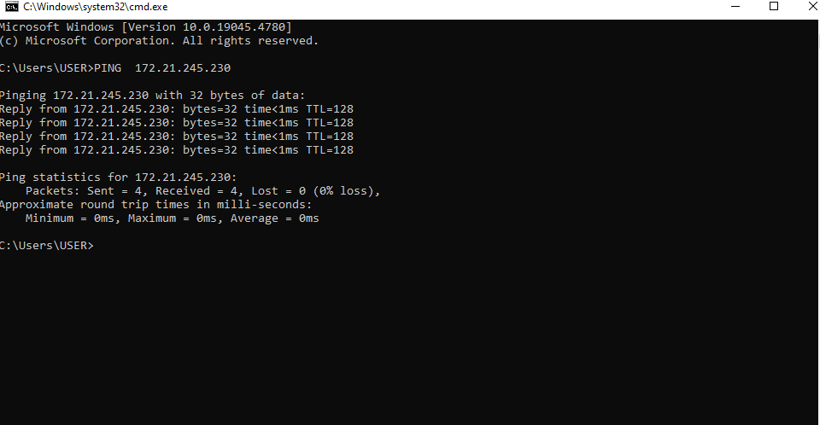

Ping uses the Internet Control Message Protocol (ICMP) echo-request and echo-reply feature to test physical connectivity. Because ping report on four attempts, it gives an indication of the reliability of the connection. Look over the result and verify that the ping was successful. Was the ping successful? If not, report to the instructor.

1. Ask the IP address of the nearby computers and ping. Note the result.

Successful

Ping the IP address of default gateway and DNS server. Were the results successful?

successful

Ping the **Loop back ip address**. Type the following address.

Ping 127.0.0.1

If loop back testing is successful then the TCP/IP is properly installed and functioning on this computer.

Is it successful? yes

Ping the host name of the computer that you recorded in previous part.

Successful

1. Ping the Microsoft website [www.microsoft.com](http://www.microsoft.com)

Successful

**Step 3: Trace the route to Riphah International University’s Website**

Type tracert [www.riphah.edu.pk](http://www.riphah.edu.pk) and press Enter key : Successful

The result shows the complete route to the website and the number of hops in the path.

Trace a local host name or IP address in your local area network (LAN).

Record the output and interpret.

successful

**Step 4: Last Practice**

Also see “pathping ip or host” command. Which only shows path from source to destination.

Successfully Ping

The **PathPing** command is a command-line network utility supplied in Windows 2000 and beyond that combines the functionality of ping with that of [tracert](https://en.wikipedia.org/wiki/Traceroute). It is used to locate spots that have network latency and network loss.

Close the window.